**Name :** Poojitha Talari

**Trainer Name :** Harshee Pitroda

**Course :** Basics of Python and ML

**Q1**

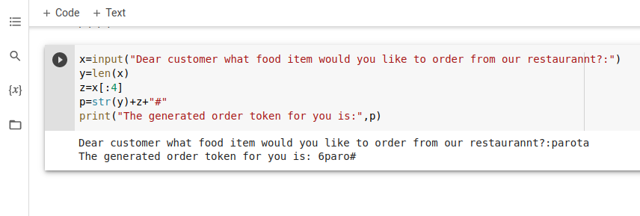

**Q2**

